Adam Zivo: How China’s propagandists bamboozled Canada’s media
Adam Zivo - 1h ago
https://www.msn.com/en-ca/news/world/adam-zivo-how-china-s-propagandists-bamboozled-canada-s-media/ar-AA11BBS6?li=AAggFp4
Last week, it was widely reported in the Canadian media that dozens of Chinese-Canadian organizations had come together to condemn an upcoming parliamentary trade mission to Taiwan. However, what was missed at the time was that the organizations in question were actually members of China’s “United Front” network, which is tasked with influencing foreign societies to Beijing’s benefit.
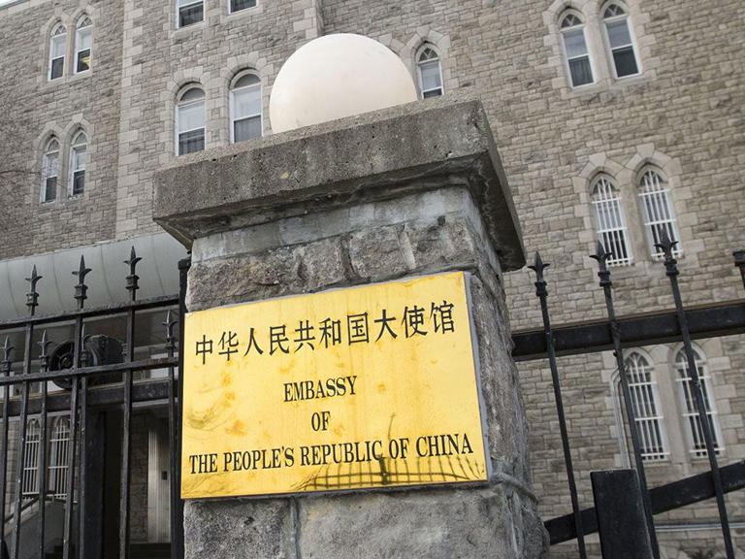
The Chinese embassy in Ottawa is seen in a file photo from 2019.© Provided by National Post
The fact that Canadian media accidentally amplified a China-led influence campaign is troubling. Journalists, as well as everyday Canadian citizens, need to learn how to better identify and call out Beijing’s propaganda.
This current incident began with a news story last week from The Canadian Press. The article, which was syndicated across several major Canadian publications, reported that dozens of Chinese-Canadian organizations had signed a public letter, published in a Chinese-language news outlet based in Canada, condemning the upcoming trade mission.
These organizations argued that “reunification” with China was the “sacred mission of all Chinese sons and daughters at home and abroad.”
Taiwan is an independent country, but Beijing contests the island’s sovereignty. It believes Taiwan is a renegade province that must be “reunified” with China — by force, if necessary — even though the Taiwanese vehemently do not want this ( a recent poll by Taipei’s National Chengchi University shows that only 6.5 per cent of Taiwanese support reunification).
China has spent decades isolating Taiwan and obstructing visits by foreign leaders to the island nation. Beijing has warned that Canada will face “forceful measures” if parliamentarians proceed with their upcoming trip, which will follow on the heels of the highly publicized visit to Taiwan by U.S. Speaker of the House Nancy Pelosi in August and other recent visits by American politicians, all of which have been condemned by China.
For this reason, the letter condemning the Taiwanese trade mission ought to have been viewed with more than a little skepticism, especially since the letter’s verbiage, and the statements made by its signatories, suspiciously mirrored Beijing’s talking points.
Instead, much real estate in the news story was given to quoting the letter’s backers. For example, David Choi, national executive chair of the National Congress of Chinese Canadians, which has a long history of pro-China advocacy, said Canada should “pause and think” and back off from being a cheerleader for the U.S.
- Federally funded Canadian group used by China to spread propaganda on Uyghurs: report
- How China uses shadowy United Front as 'magic weapon' to try to extend its influence in Canada
The story also referred to a story published in the China Daily, which is owned by the Chinese government, in which Choi was quoted as saying Canada’s 1.8 million Chinese Canadians would be “disgusted” if Taiwan was used as a pawn in conflict. Choi did not explain how he could speak on behalf of the entire Chinese-Canadian community, but no matter, China’s state media has been using comments such as his to create a fantasyland wherein all Chinese-Canadians aggressively oppose Taiwanese independence (a major domestic propaganda win).
Meanwhile, Pifeng Hu, honorary president of the Richmond, B.C.-based Peace and Development Forum of Canada, was quoted as saying that the anti-Taiwan letter was arranged simply because, “We still have feelings for our country of origin and the hometowns we grew up in,” and that it was sad to see the Taiwanese and Chinese argue with each other.
Hu’s narrative was cute — it’s too bad that the main organizations behind the letter have been verified as members of China’s United Front.
The United Front is a network of Beijing-controlled organizations that, collectively, allow China to engage in extensive influence campaigns that compromise politicians, business leaders and academics throughout the world.
These networks also harass dissidents and human rights activists — for example, United Front groups have, on several occasions, intimidated Tibetan and Uyghur activists speaking on Canadian campuses. At Hamilton’s McMaster University, Chinese students anonymously expressed fear of a United Front student organization that reported on campus activities to the Chinese government.
The Canadian Security Intelligence Service, which believes that Canada is an “attractive and permissive” target for Chinese interference, has identified United Front as a threat that must be reduced .
But it’s not always easy to know which organizations are part of United Front. Joanna Chiu, author of China Unbound (a widely celebrated book that examines China’s influence campaigns), says these organizations use language barriers to conceal their affiliations.
“The Chinese versions of their websites, made for Chinese-speaking audiences, often very plainly boast of the organization’s connections with the Chinese government, while the language in English tends to be generic and emphasize cultural activities.”
It can also be hard to show that government connections necessarily amount to propaganda work. In this case, however, there is no ambiguity.
In 2017, the Chinese government published a document that literally listed out which international organizations were part of its United Front network, and then, in 2018, it published another document listing agents being sent abroad to “Do ‘combat’ for Socialism with Chinese Characteristics for a New Era,” and “act on behalf of comrade Xi Jinping.”
Surprise, surprise: many of the organizations and figures associated with the anti-Taiwan letter were on these lists, including individuals quoted in The Canadian Press article .
This information wasn’t hard to find. Two political consultants, Jamie Ellerton and Dominic Stewart, came across it during an afternoon of casual sleuthing and then posted their findings in a Twitter thread . While the original 2017 Chinese government document no longer exists, I was able to use the Wayback Machine to access an archived version , thereby verifying its content.
Additionally, it took very little effort to find the transcript of a 2020 meeting of the Special Committee on Canada-China Relations , in which Victor Ho, a Democracy activist and retired editor-in-chief of Sing Tao Daily (one of Canada’s largest Chinese-language newspapers), spoke about United Front’s influence on Canadian media and identified many of these Chinese organizations as United Front agents.
But even though these organizations and individuals have been explicitly identified as China’s puppets, and even though this compromising information is easily accessible, Beijing’s propaganda was still presented as the authentic, though contentious, expression of many Chinese-Canadians.
“It is our responsibility as journalists, researchers and citizens to equip ourselves with basic awareness to know what to look out for,” says Chiu, whose book laments the “unchecked” influence of United Front.
“Google translate works really well and in many cases it’s easy to do a basic background check of these organizations before taking what they say at face value or portraying their views as representative of Canadians of Chinese descent,” she says.
However, even if journalists improve their practices, foreign influence campaigns, whether from China or elsewhere, will find ways to confound the media. Ultimately, we need legislation that forcibly exposes foreign agents.
In November, Sen. Leo Housakos tabled a new bill, S-237 , which would create a registry for foreign agents akin to what is already done for corporate lobbyists. The bill however has become stalled in the Senate, and Housakos says he is irritated by his colleagues’ complacency on the issue.
“My biggest disappointment is that there are colleagues of mine in the Senate who have defended Beijing using similar talking points to what we’ve seen in United Front organizations in Canada,” he said, suggesting that the problem does indeed run very deep.
National Post

